Chapter 13, Problem 68.

In the ideal autotransformer of Fig. 13.131, calculate I₁, I₂, and I_{o}. Find the average power delivered to the load.

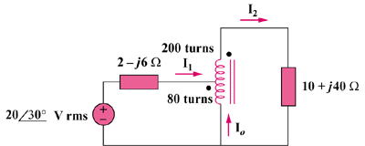

Figure 13.131
For Prob. 13.68.

